**Troubleshooting docker build:**

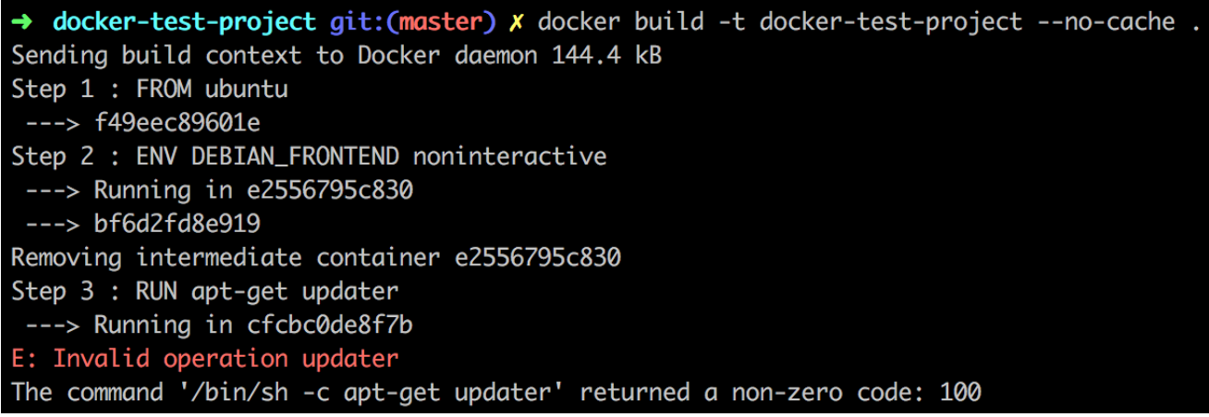

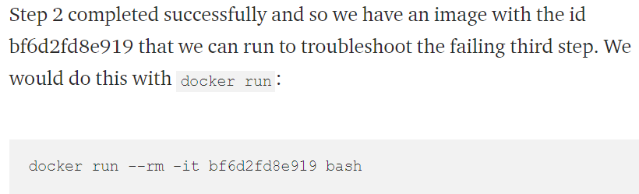

As above, we can see it was successful till step2. So, we can run the image which got created at step2 and try to troubleshoot the issue